**Topic:** About Myanmar

**EQ:** How can we develop a website to promote tourist attraction places and culture of myanmar **?**

**Color scheme: Orange, Yellow , Brown**

**Font style: -**

**Wireframe**

Home = 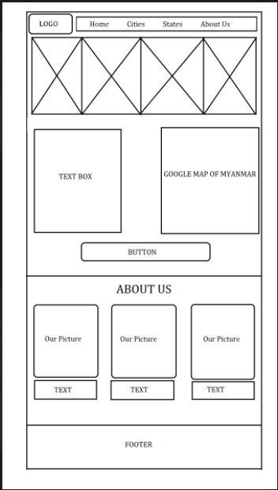

States = 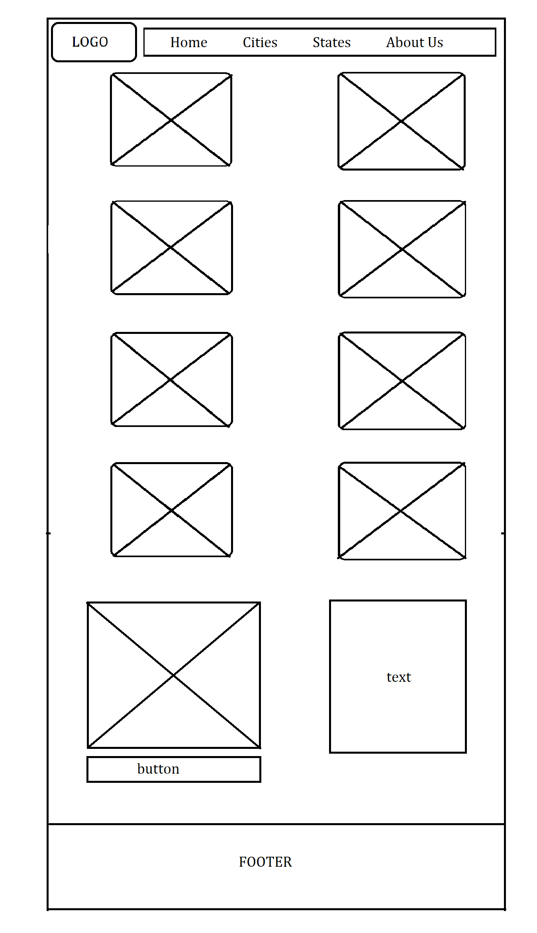

Cities = 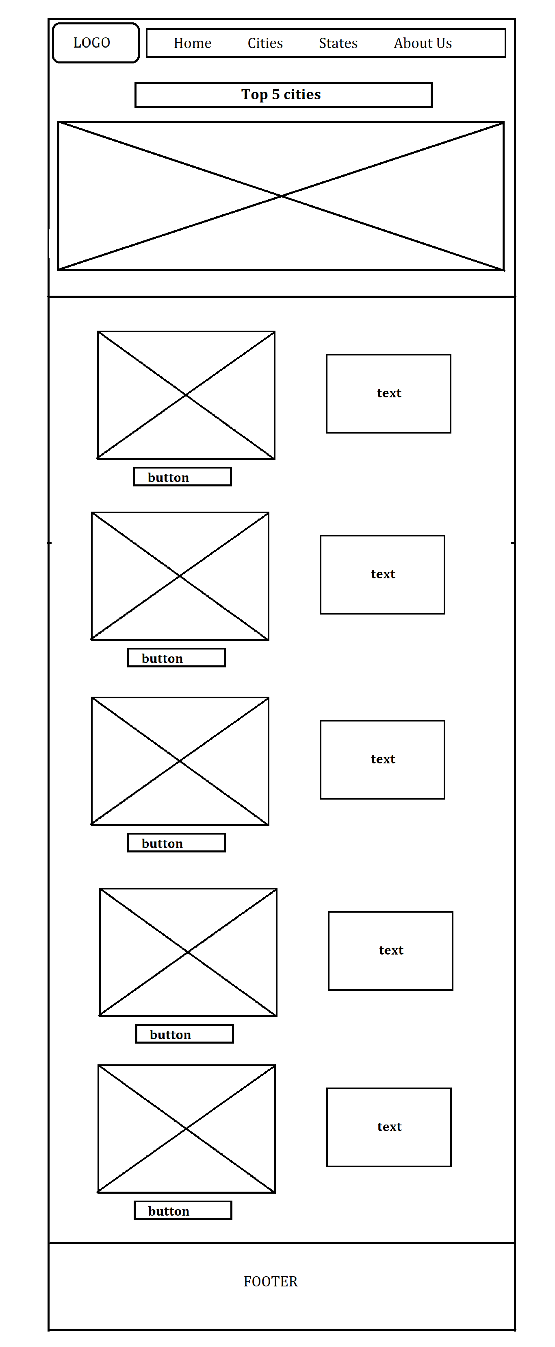

About us = 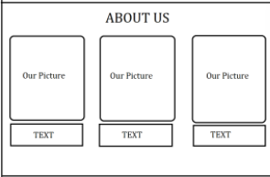

Home Page



**Ref Link:**

* [**www.google.com**](http://www.google.com)
* [c4.wallpaperflare.com](https://www.google.com/url?q=https://c4.wallpaperflare.com/wallpaper/256/7/701/shwedagon-pagoda-2-wallpaper-preview.jpg&usg=AOvVaw1HeCl7x-5aokU7iWA5usiD)
* [media.istockphoto.com](https://www.google.com/url?q=https://media.istockphoto.com/id/504077406/photo/shwedagon-pagoda.jpg%3Fs%3D612x612%26w%3D0%26k%3D20%26c%3Dccp3L0-ey-oFGLrmnREpPbiFXxgTYp3_waq-VpviZ44%3D&usg=AOvVaw0qmY1H_Mon3DaTJy_iqvOe)
* [wallpaperaccess.com](https://www.google.com/url?q=https://wallpaperaccess.com/full/2699839.jpg&usg=AOvVaw21yDo-1z7sta5GbwLDtIa6)
* [i.pinimg.com](https://www.google.com/url?q=https://i.pinimg.com/originals/5e/e8/b1/5ee8b12c68bdaad6414f7f28d62e43b2.jpg&usg=AOvVaw1AesijSCU8EE5DWbeMTXh5)
* [thumbs.dreamstime.com](https://www.google.com/url?q=https://thumbs.dreamstime.com/b/aerial-shot-beautiful-city-bago-myanmar-its-beautiful-temples-under-cloudy-sky-aerial-shot-beautiful-181469902.jpg&usg=AOvVaw1DKXpuFLCuLUGUYMdkPRLs)
* [mingalago.com](https://www.google.com/url?q=https://mingalago.com/media/2019/03/Bago-Region_4.jpg&usg=AOvVaw1ne0njkc4Ywj6Q4GwMOKhN)
* [dailytravelpill.com](https://www.google.com/url?q=https://dailytravelpill.com/wp-content/uploads/2018/12/things-to-do-in-Mawlamyine-3.jpg&usg=AOvVaw1O2Ty6vNF6GsUh_mXQxBYk)
* [gomyanmartours.com](https://www.google.com/url?q=https://www.gomyanmartours.com/wp-content/uploads/2015/04/Naypyidaw-Tours.jpg&usg=AOvVaw1rVmAC6Ke8uQ-_F2GtsaG3)
* [media.worldnomads.com](https://www.google.com/url?q=https://media.worldnomads.com/social-share-images/myanmar/naypyidaw-social.jpg&usg=AOvVaw0N2DTBU3LtMtwZQnU9iClX)
* [flymna.com](https://www.google.com/url?q=https://www.flymna.com/content/filebank%3Fid%3D587407ce-aaf7-4e34-a825-f21114757cce&usg=AOvVaw0e7D0T1rss8ICnLipgXLNd)
* [img.i-scmp.com](https://www.google.com/url?q=https://img.i-scmp.com/cdn-cgi/image/fit%3Dcontain,width%3D1098,format%3Dauto/sites/default/files/styles/1200x800/public/d8/images/methode/2019/07/12/7780b5d8-a15b-11e9-9a3c-98259c87fba2_image_hires_173133.jpg%3Fitok%3DdIxb7Ogq%26v%3D1562923901&usg=AOvVaw14rThqK9rv4FnqkOnN58uZ)
* [media.gettyimages.com](https://www.google.com/url?q=https://media.gettyimages.com/id/1359272339/video/aerial-view-kyeik-than-lan-pagoda-pagoda-in-mawlamyine-mon-state-myanmar.jpg%3Fs%3D640x640%26k%3D20%26c%3DUU1mBXQWA9gGopHfo5gSbgBO-2Pnr6dt0412-LCok3s%3D&usg=AOvVaw0lBDTKS72lDNHVjWoWuzEN)
* [gomyanmartours.com](https://www.google.com/url?q=https://www.gomyanmartours.com/wp-content/uploads/2014/11/Nay-Pyi-Taw-the-capital-city-of-Myanmar.jpg&usg=AOvVaw22fiI_dCSJ9a6awu7nt2WS)
* [c1.wallpaperflare.com](https://www.google.com/url?q=https://c1.wallpaperflare.com/preview/159/624/970/mandalay-burma-pagoda-temple.jpg&usg=AOvVaw1Tt5sC6L-dcFNdXgotDm8r)
* <https://www.wikipedia.org/>
* <https://fontawesome.com/>

[**https://www.travelmath.com/cities-in/Myanmar**](https://www.travelmath.com/cities-in/Myanmar)